

Internal Assessment Resource
Digital Technologies & Hangarau Matihiko Level 2
This resource supports assessment against Achievement Standard 91890 & 91891
Standard title: 91890 Conduct an inquiry to propose a digital technologies outcome (6 credits)
91891 Apply conventions to develop a design for a digital technologies outcome (3 credits)
Credits: 9
Resource title: What would make a good digital outcome?
Resource reference: Digital Technologies & Hangarau Matihiko 2.1B_2.2A
This resource:
- Clarifies the requirements of the achievement standard
- Supports good assessment practice
- Should be subjected to the school’s usual assessment quality assurance process
- Should be modified to make the context relevant to students in their school/kura environment and ensure that submitted evidence is authentic

Authenticity of evidence | Teachers/kaiako must manage authenticity for any assessment from a public source, because students may have access to the assessment schedule or student exemplar material.  Using this assessment resource without modification may mean that students’ work is not authentic. The teacher may need to change figures, measurements or data sources or set a different context or topic to be investigated or a different text to read or perform.
¹Achievement standards 91890 & 91891 are derived from both The New Zealand Curriculum and Te Marautanga o Aotearoa.
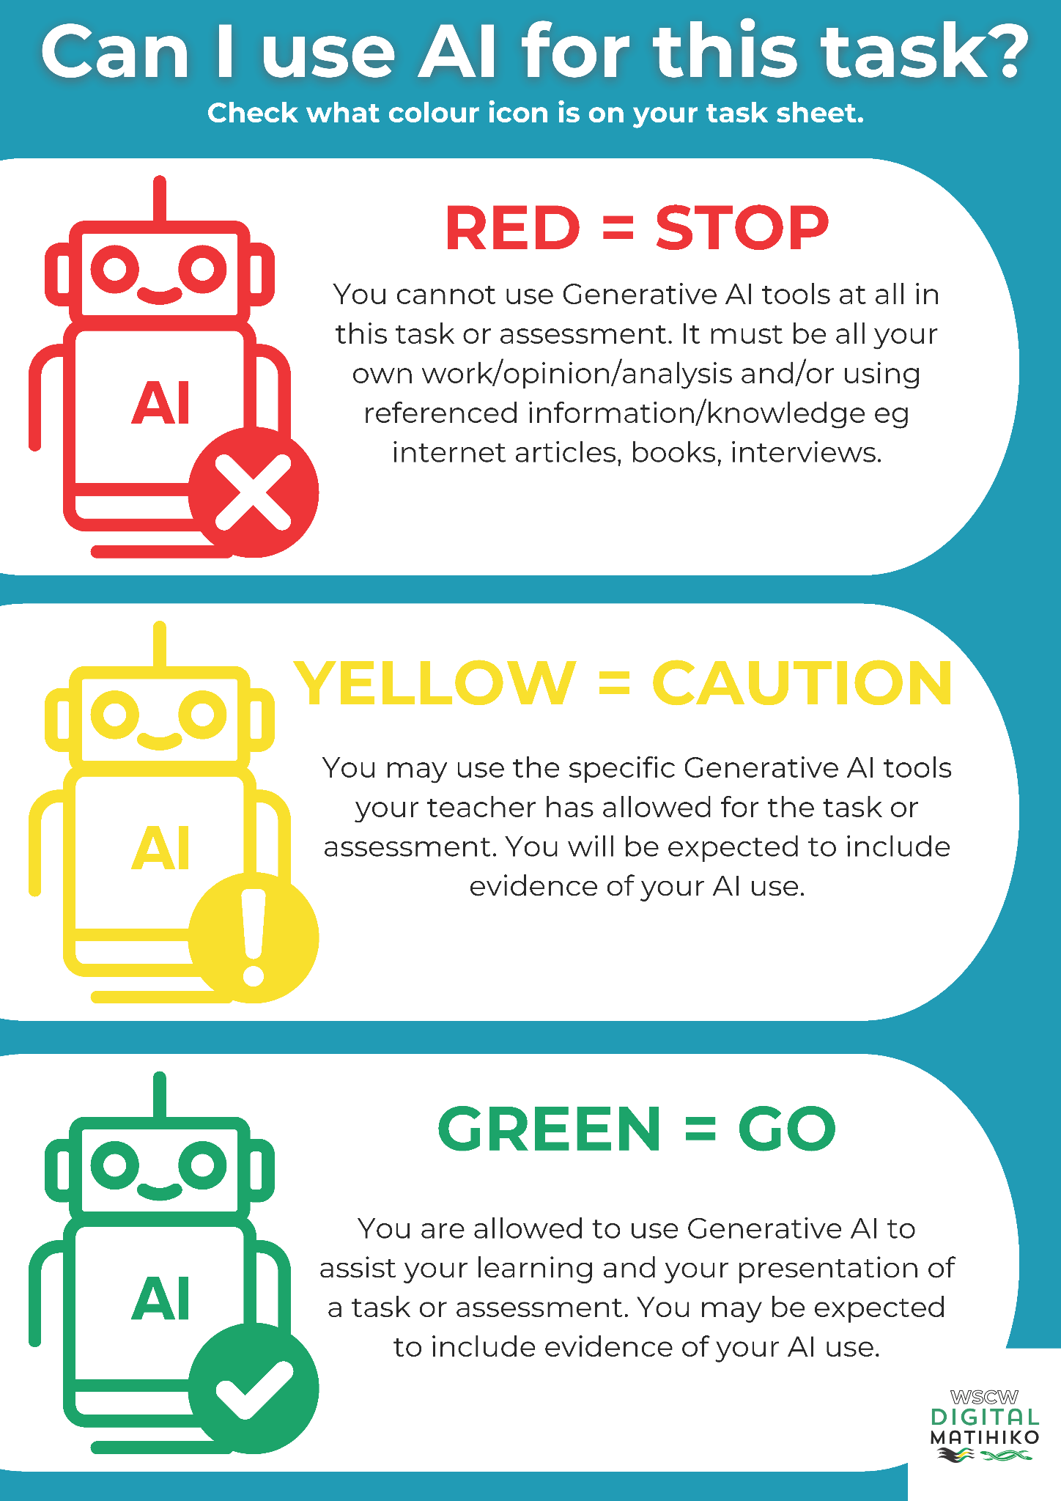

Student Assessment Resource
Achievement standard: 91890 and 91891
Standard title: 2.1 Conduct an inquiry to propose a digital technologies outcome
(6 credits)
2.2 Apply conventions to develop a design for a digital technologies outcome (3 credits)
Credits: 9
Resource title: What makes a good digital outcome?
Resource reference: Digital Technologies & Hangarau Matihiko 2.1B_2.2A
Student/Akonga instructions

Introduction/Kupu Arataki
So, you know you want to create something digital? Maybe you already have an idea, or maybe you're still figuring it out. Either way, great digital outcomes don’t just happen—they take careful planning and design to make sure they actually work, look good, and are easy to use.
The big, curious question you need to explore is: WHAT FOR? or WHY?
You’ll be given a choice of context to focus your inquiry on. From there, you'll dig into something that interests you—figuring out what you already know, what you need to learn, and how you’ll go about finding that out. This isn’t just about getting an answer—it’s about the journey. You’ll be assessed on how well you research and develop an idea for a digital outcome that could help solve a problem.
Next comes the design ideas.
What will make your digital outcome successful? Is it how users interact with it? The problem it solves? The way it presents information? Maybe it’s the smooth interaction and intuitive controls, or the creativity behind its design. A good digital solution should be accessible, visually appealing, and provide real value to the end user.
You likely have more questions than answers—like which of these elements will matter most in your digital outcome and how you can design them to create a compelling experience.
That’s where your inquiry begins.
Due Date: 9am, MONDAY 20 APRIL 2026
Review 1 from: 23 February
Review 2 from: 9 March
Review 3 from: 23 March

INQUIRY REPORT WORD COUNT LIMITS: Between 2500 and 5000

Task/Hei Mahi
This task involves conducting an inquiry into your chosen digital outcome idea and, through your investigation, making a justified proposal. To ensure the inquiry is manageable, milestones must be agreed upon as part of the Achieved criteria.
For the design task, you’ll explore key elements of digital outcomes:
- User Interface (UI): How users interact with your outcome visually.
- User Experience (UX): How intuitive and enjoyable the experience is.
- Functionality: How well the outcome performs its intended purpose.
- Aesthetics: The visual and auditory aspects that enhance engagement.
- Interactivity: How users engage with and control it.
- Accessibility: How inclusive and usable your outcome is.
You can brainstorm with others, but you’ll need to show your own thinking—how you discussed and combined ideas—before submitting your own work.

Inquiry

All INQUIRY tasks must be completed without the use of any generative AI.

Managing project timelines
Plan and design your timeframe with key milestones and inquiry progressions. Share this with your teacher. You will need to provide evidence of using your plan to guide and manage your inquiry. For example, use a project management tool such as Trello, diary, stickies, online calendar or other relevant tool.

Refer to Appendix A for a sample timeline guide, or you may use this Trello Board

Inquiry question/s:
Decide on an inquiry focus and develop question/s that will guide your inquiry and development of your digital outcome.
You are to develop an inquiry question that has relevance to you and our school community that relates to your inquiry focus. You also need to consider how digital technologies can be used to address the inquiry question.
Use Appendix B to help you to frame your inquiry question.

Find out, research
Undertake research to gather background information and ideas from reliable, expert sources. Use this Research Template to guide your research.

Make meaning, organise, analyse
Analyse your gathered information. Within your analysis you also need to:
  - compare and contrast different perspectives that relate to the inquiry focus (e.g. members, stakeholders, media, customers, owners)
  - decide how this information will inform your digital outcome.
** Remember to use the Research Template to guide your research

So what?
Establish a refined inquiry focus.

Take action
  - Propose a digital outcome to the inquiry focus.
  - Make sure you include the purpose of the digital outcome, end users, what it will do or needs to do (requirements and specifications), and resources needed to create the digital technologies outcome.
  - Explain any relevant risks and ways to mitigate these risks. For example, access to resources, incorrect functionality or content, scope of the proposed outcome, time requirements, device compatibility, excessive screen time, accessibility issues.

Reflection, evaluation
Evaluating and reporting on the findings from the digital technologies idea or solution in relation to the inquiry question(s). Make sure your evaluation makes links to:
  - Critiquing the accuracy, relevance, reliability, and/or significance of the findings
  - Discussing possible future opportunities relating to the inquiry focus and Explaining the possible impacts of these opportunities.
  - Considering possible issues relating to the inquiry focus and suggesting areas for improvement, extension, and/or follow-up.
  - Evaluating the strengths and weaknesses of the proposed digital technologies outcome

Design

Some DESIGN tasks maybe completed with generative AI - check with your teacher, first.

This is where you will use some rules and creative thinking to come up with a design for your proposed digital outcome.

Research
What will make your digital outcome successful? Is it how users interact with it? The problem it solves? The way it presents information? Maybe it’s the smooth interaction and intuitive controls, or the creativity behind its design.
A good digital solution should be accessible, visually appealing, and provide real value to the end user.

Common Design Conventions
Here are some common conventions that can feature across different outcomes or different genres.
  - User Interface (UI): How users interact with your outcome visually.
  - User Experience (UX): How intuitive and enjoyable the experience is.
  - Functionality: How well the outcome performs its intended purpose.
  - Aesthetics: The visual and auditory aspects that enhance engagement.
  - Interactivity: How users engage with and control it.
  - Accessibility: How inclusive and usable your outcome is.

Relevant Implications
You’ll also need to think about the implications of your proposed outcome to ensure it will be successful when used. For example:
  - Social: Will it have a positive impact?
  - Intellectual property: Who owns the ideas, images and text?
  - Accessibility: Can anyone access it on any device?
  - Future proofing: Can it be kept up to date?
  - Ethical: Is it moral? Is it right?
  - Privacy: Is data kept private?
  - End user considerations: What specific needs does your end-user have?
  - Aesthetics: Does it look good?
  - Legal: Does it obey all relevant laws?
  - Functionality: Does it work well?
  - Usability: Is it easy to use?
  - Cultural: Is it culturally appropriate?
  - Health & Safety: Is it safe to use?

Modelling
Generate and model a range of design ideas using conventions. Then, select a design and explain the appropriateness of the design. Use feedback gained from modelling to improve the design.

Justification
Justify how your chosen design addresses implications, end-user considerations and uses appropriate conventions. This should come after your final designs. Again, be explicit about how the above conventions (key elements) are necessary in your design.

Final collation and Hand-in
Use the Student Self- Check Checklist (APPENDIX C) as your guide to ensure you have covered everything and that your work is ready for submission.
Check the Assessment Schedule (APPENDIX D) and critique your work against the assessment schedule.

APPENDIX A - KEY DATES/MILESTONES
Key Milestones  Project Due Date: | Done  ✅
INITIAL MILESTONES TIMELINE completed by end of WEEK 3 of term 1
- Share with your teacher no later than Week 3 of the term
DRAFT INQUIRY QUESTION completed by end of WEEK 4 of term 1
- Share your draft inquiry question and make time to discuss with your teacher.
- Start your initial research in Week 4
REVIEW #1: SHARE INQUIRY QUESTION by end of WEEK 5 of term 1
- This is a brief stand-up presentation to the class – outlining your inquiry question and why it is of interest to you.
- You should have started your initial research in Week 4 so should have some ideas about why you have proposed the inquiry question and what approaches you will take to research and perhaps resolve the question.
RESEARCH AND ANALYSIS completed by end of WEEK 6 of term 1
- Share your research folder and your refined inquiry question with your teacher no later than Friday of Week 6
- Make a time to meet with your teacher to discuss your research, your refined inquiry question and next steps
REVIEW #2: SHARE PROPOSED SOLUTION by end of WEEK 7 of term 1
- This is a brief stand-up presentation to the class - outlining what digital outcome you have decided to make and one resource you’ll use to make it
DESIGN CONCEPTS AND REFINEMENTS by end of WEEK 8 of term 1
- Share your initial design concepts with your teacher no later than Friday Week 8
- Make a time to meet with your teacher to discuss your concepts, your refinements and next design steps
REVIEW #3: SHARE RANGE OF DESIGN CONCEPTS by end of WEEK 9 of term 1
- This is a brief stand-up presentation to the class - outlining one possible design of your chosen digital outcome
EVALUATION AND REPORT SUBMISSION by beginning of WEEK 1, term 2
- Use the Student Self Check to make sure you have met all aspects of the assessment
- Check your work against the assessment schedule (APPENDIX D) - have you met all the Achieved, Merit and Excellence criteria?
- All work to be handed in at the very beginning of Term 2

APPENDIX B - FRAMING YOUR INQUIRY
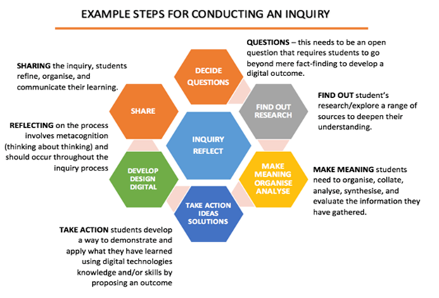
Inquiry question/s:
Decide on an inquiry focus and develop question/s that will guide your inquiry and development of your digital outcome. Your inquiry question should be open-ended, where you focus on the process - not the solution.
Use the following prompts to help you to start composing your inquiry question:

FRAMING WORDS - start your inquiry question with one of the following framing words:
What ideas am I interested in?
What do I know about the topic?
How do I know about it?
What experience do I have with this topic?
What do I want to know?
What am I wondering?
What are my questions?
What am I feeling?
- How can ….
- How do ….
- Should …..
- Could …..
- What ….

PERSON / IDENTITY - now add the person/s or identity of the situation.
- I / we…
- We as (roles or occupations)
- Town / city
- Country
- Community or organisation

ACTION OR CHALLENGE - state what the challenge or action is:
- Build / Create / Make ….
- Design / plan ….
- Solve ….
- Write ….
- Propose / decide ….

AUDIENCE OR PURPOSE - state what the problem is and the purpose or audience you are helping.
- Real world problem ….
- For a public audience …..
- For a school ….
- For a classroom ….
- For a company ….
- For an online audience ….

Example of an inquiry question:
How can Auckland City Mission create a more systematic and streamlined way to track and access unsold food and food products from supermarkets and restaurants and distribute these products to families in need?

Managing project timelines
Plan and design your timeframe with key milestones and inquiry progressions.
Think about the deadline for handing your proposal in and work backward.
You will need to provide evidence of using your plan to guide and manage your inquiry.

Find out, research
Undertake research to gather background information and ideas from reliable, expert sources.
Look at various ways you could answer your inquiry question and solve the problem.

Use the Research Template on the next page to help you to keep evidence and track your research.

Research Template
blank editable copy available here

Information / Research
Author
Name of Article
Name of Publication
Web Address (if online)
Date Published
Describe the article briefly
What are 1-2 key points that this source can contribute to your research?
What is 1 direct quote you can use as your evidence?
Which part of my inquiry does this information support? (relevance / significance)
Have any of your thoughts or ideas changed after reading or viewing this text?
What is different or new now that you have read this?
PLUS: What are the positive or useful aspects from this article/website?
MINUS: How has this changed your perspective or thoughts on an outcome?
INTERESTING: Are there implications for consideration? How will this information inform your digital outcome?

Make meaning, organise, analyse
Analyse your gathered information. Within your analysis you also need to:
· compare and contrast different perspectives that relate to the inquiry focus.
· decide how this information will inform your digital outcome.

So what?
Now that you have undertaken your research, refine your question and propose your solution to the question.
Establish a refined inquiry focus.
Initial Question:
How can game-based learning be used to educate Year 7 students at FDMC about sustainability in an interesting and entertaining way?
Refined Question:
How can the libGDX library for Java be used to create a 2D game to educate Year 7 students at [name school] about sustainability in an engaging yet challenging way?

Take action
· Propose a digital outcome to the inquiry focus.
· Be very clear about the purpose of the digital outcome, what it will do or needs to do (requirements and specifications), who the end users will be, and any resources needed to create the digital technologies outcome.

Reflection, Evaluation
Evaluate and report on the findings from the digital technologies idea or solution in relation to the inquiry question(s).

APPENDIX C - STUDENT SELF-CHECKLIST
Checklist for AS91890  If you have followed the guidelines, you should be meeting the standard criteria. However, it is good to ask yourself some final “self-check” questions. When reading over your work, ask yourself: | Done  ✅
Conduct an Inquiry to Propose a Digital Technologies Outcome - 6 Credits
General Inquiry Tasks
- I have clearly stated an inquiry question.
- My inquiry question is linked to a digital technologies context.
- I have identified the focus of my inquiry and explained why it is relevant.
Research and Analysis
- I have gathered information from multiple sources relevant to my inquiry.
- I have organised my research into categories or themes.
- I have analysed the information to identify trends, patterns, or gaps.
Proposing an Outcome
- I have described the purpose of my proposed digital technologies outcome.
- I have identified who the end users are and their needs.
- I have clearly defined the scope of the project (what it will and will not include).
- I have outlined the requirements and specifications for the outcome.
- I have listed the resources needed to create the outcome.
Reflection and Reporting
- I have summarised how my research findings support my proposed outcome.
- I have addressed relevant implications, such as accessibility, privacy, or sustainability.
- I have met the milestones I set for my inquiry.
Advanced Inquiry (for Merit and Excellence)
- I have analysed the implications and perspectives that impact my proposed outcome.
- I have discussed how my findings influenced my proposed design decisions.
- I have drawn insightful conclusions about my research findings in relation to my inquiry question.

Checklist for AS91891  If you have followed the guidelines, you should be meeting the standard criteria. However, it is good to ask yourself some final “self-check” questions. When reading over your work, ask yourself: | Done  ✅
Apply Conventions to Develop a Design for a Digital Technologies Outcome - 3 credits
Planning the Design
- I have described the purpose of the outcome and the needs of the end users.
- I have researched relevant design conventions and documented my findings.
- I have identified the most relevant implications of my design and described their meaning
Generating and Refining Ideas
- I have generated at least three design ideas and modeled them (e.g., through sketches or digital mockups).
- If have used generative AI to assist with my design ideas, I have provided the related link to all my AI prompts or discussions
- I have selected a final design and explained why it is the most appropriate.
- I have used feedback from modeling to refine my design.
Explaining the Design
- I have explained how my design uses appropriate conventions.
- I have addressed the named implications by incorporating them into my design ideas
- I have considered how my design meets the requirements of the end users.
Advanced Design (for Merit and Excellence)
- I have justified how my design addresses end-user needs and implications.
- I have explained how conventions were applied to enhance the quality of the design.
- I have reflected on how feedback and iterative improvements enhanced my design.

APPENDIX D - ASSESSMENT SCHEDULE - 91890
Evidence/Judgements for Achievement/Paetae | Evidence/Judgements for Achievement with Merit/Kaiaka | Evidence/Judgements for Achievement with Excellence/Kairangi
Conduct an inquiry to propose a digital technologies outcome involves:  - Deciding on an inquiry focus and developing an inquiry question(s) linked to digital technologies  For example: The student identified a need for an educational app to help high school students learn coding concepts. They framed their inquiry question as, "How can digital tools be designed to make learning coding more interactive and accessible for high school students?"  The student has: A clearly stated inquiry question, supported by a brief rationale or background explaining the relevance of the focus area.  - Undertaking research to gather information  For example: The student researched existing educational apps, user feedback, and relevant educational theories to understand what features support learning engagement.  The student has: A research log with summaries, links, and brief notes on key resources used, showing the breadth and relevance of information gathered.  - Organising and analysing information  For example: After gathering research, the student organised it into categories, such as "Effective User Interfaces," "Gamification in Learning," and "Accessibility Features," and analysed common patterns or gaps in existing tools.  The student has: An outline or mind map of organised categories with short notes explaining findings within each category, helping to frame the proposed outcome.  - Proposing a digital technologies outcome to the inquiry  For example: Based on the research, the student proposed a prototype for a coding app that uses gamified quizzes and interactive tutorials to improve engagement. The proposal includes detailed information to guide the outcome’s development, such as the app’s purpose (to make coding accessible for high school students), identification of end users (students aged 13-18), a defined scope (focus on foundational coding skills with three core sections: tutorials, practice exercises, and progress tracking), requirements and specifications (touchscreen compatibility, interactive feedback), and a list of resources needed (coding platform, graphics software, testing devices).  The student has: A comprehensive summary of the proposed outcome, supported by a visual or written description detailing purpose, end users, scope, specifications, and required resources, ensuring a clear development pathway based on research findings.  - Summarising the findings of the research in relation to the inquiry question(s) and the proposed outcome  For example: The student concluded that a combination of gamification and accessibility features would make coding more engaging and accessible, directly answering the inquiry question.  The student has: A one-page summary or slide that connects findings back to the inquiry question and explains how the proposed outcome addresses identified needs.  - Establishing and meeting agreed milestones of the inquiry  For example: The student set up milestones, such as "Complete initial research," "Analyze findings," "Draft proposal," and "Finalise outcome proposal," tracking their progress weekly.  The student has: A project timeline, Trello board or Gantt chart with dates and notes showing completion of each milestone, along with any adjustments made along the way. | Conduct an in-depth inquiry to propose a digital technologies outcome involves:  - Analysing the implications and perspectives that impact on the proposed outcome  For example: The student examined user privacy implications and ethical considerations of using data to tailor educational content, discussing how this would affect user trust.  The student has: A written analysis or presentation slide that details specific implications, such as data privacy, accessibility for diverse learners, and the educational impact, with brief justifications for each.  - Discussing the impact of the findings of the research in relation to the inquiry question(s) and the proposed outcome  For example: The student reflected on how their research findings revealed a strong need for accessibility features, leading them to propose more inclusive design options in the app.  The student has: A reflective statement or summary that ties research insights directly to adjustments in the proposed outcome, such as improved design elements or added functionalities based on user needs. | Conduct a comprehensive inquiry to propose a digital technologies outcome involves:  - Drawing insightful conclusions about the findings of the research in relation to the inquiry question(s) and the proposed outcome  For example: After completing the inquiry, the student concluded that engagement in educational apps is most effectively sustained through a balance of user control, gamification, and adaptive learning paths. They proposed that these elements be central to the app design.  The student has: A conclusion paragraph or slide that presents a synthesis of research insights, providing a clear and reasoned answer to the inquiry question and a finalised design concept for the app.

APPENDIX D - ASSESSMENT SCHEDULE - 91891
Evidence/Judgements for Achievement/Paetae | Evidence/Judgements for Achievement with Merit/Kaiaka | Evidence/Judgements for Achievement with Excellence/Kairangi
Apply conventions to develop a design for a digital technologies outcome involves:  - Describing the purpose of the outcome and the requirements of the end users  For example: The student outlined that the purpose of the outcome is to create an interactive website for teens to learn about sustainability. They specified that end users (ages 13-18) prefer visuals, interactive content, and intuitive navigation to enhance learning engagement.  The student has: A description of the outcome’s purpose, with a clear list of end-user needs and preferences that guide design decisions.  - Investigating and applying relevant conventions  For example: The student researched design conventions for educational websites, including clean layouts, readable fonts, and engaging visuals. They applied these conventions by using a three-column grid layout, consistent font styles, and a green color scheme to align with the theme of sustainability.  The student has: Screenshots or sketches that demonstrate the application of design conventions, with brief notes on each convention used and how it supports the purpose and end-user experience.  ❏ Generating and modelling a range of design ideas  For example: The student sketched multiple layout ideas, exploring different placements for navigation, content sections, and interactive features to optimise accessibility and engagement.  The student has: A minimum of three design sketches or digital wireframes, each labeled with variations and features considered, showing a range of ideas to support effective design.  ❏ Selecting a design for the purpose of the outcome and explaining the appropriateness of the design  For example: The student chose a design with a simple navigation bar and engaging homepage visuals, explaining that this layout makes content easily accessible and visually appealing to the teenage audience.  The student has: A chosen design annotated with explanations on why this layout is suitable for the purpose and audience needs, emphasising ease of use and aesthetic appeal.  ❏ Explaining relevant implications  For example: The student addressed the need for accessibility by using high-contrast colors and including alt text for images, ensuring that the design is inclusive and accessible for all users.  The student has: A list of design choices that address implications, such as accessibility, usability, and alignment with educational goals, showing insight towards end-user needs. | Apply conventions to develop an informed design for a digital technologies outcome involves:  - Using feedback gained from modelling to improve the design:  For example: The student gathered peer feedback on an initial website mock-up, where users suggested simplifying the navigation. The student responded by condensing navigation options into a dropdown menu to streamline the layout.  The student has: A summary of feedback received, along with before-and-after screenshots showing design adjustments made in response to the feedback.  - Explaining how the chosen design uses appropriate conventions  For example: The student explained how their chosen design employs conventions like clear headings, consistent font sizes, and organised content sections, all of which are typical for educational websites and support user engagement.  The student has: An explanation document or slide detailing how the final design applies industry conventions to achieve clarity, usability, and visual appeal.  - Addressing relevant implications and end-user considerations  For example: The student considered implications like data privacy by including clear privacy statements for interactive elements that collect user input, making sure the website aligns with ethical standards.  The student has: A brief document summarising steps taken to address implications and end-user considerations, including accessibility, privacy, and end-user considered features. | Apply conventions to develop a refined design for a digital technologies outcome involves:  - Justifying how the chosen design addresses implications, end-user considerations, and uses appropriate conventions  For example: The student justified that their final design not only uses clear educational conventions (like structured layouts and simple navigation) but also incorporates accessibility features and feedback, meeting both user needs and design best practices.  The student has: A written justification or presentation slide that outlines how the design thoughtfully addresses all relevant aspects—implications, user needs, and conventions — demonstrating a deep understanding of design considerations.
Final grades will be decided using professional judgement based on a holistic examination of the evidence provided against the criteria in the achievement standard

APPENDIX E - SELF EVALUATION

SELF REFLECTION ON PROJECT WORK - STUDENT VOICE
Think about what you did in this research project, and how well the project went
Student Name
Project Focus / Inquiry Question
Software used
Target users / End Users
ABOUT YOURSELF
What was the most important thing you learned in this project?
What do you wish you had spent more time on, or done differently?
What part of the project did you do your best work on?
What have you learned about yourself during this project? (strengths, work-ons, interests)?
ABOUT THE PROJECT
What was the most enjoyable part of the project?
What was the least enjoyable part of the project?
How could your teacher change the project to make it more manageable or enjoyable next time?

